Portfolio
HTML Code :
<!DOCTYPE html>
<html lang="en">
<head>
<meta charset="UTF-8" />
<meta name="viewport" content="width=device-width, initial-scale=1.0" />
<title>My Portfolio</title>
<link rel="stylesheet" href="CSS2/style.css ">
</head>

<body>

<!-- ===== HOME SECTION ===== -->
<header id="home">
<div class="home-content">
<img src="profile 3.jpg" alt="profile" class="profile-img">
<h1>Hi, I'm Stuti Gupta</h1>
<h3>B.Tech 1st Year | CSE (AI & ML)</h3>
<p class="tagline">Aspiring AI Engineer | Tech Enthusiast</p>
</div>
</header>

<!-- ===== ABOUT SECTION ===== -->
<section id="about" class="section">
<h2>About Me</h2>
<p>
I am a first-year B.Tech CSE (AI & ML) student with a passion for technology,
coding, and creative problem-solving. I enjoy learning new tools, building small
projects, and exploring AI concepts. My hobbies include reading,singing, dancing, designing,
and learning about new innovations. My goal is to become a skilled AI engineer and
contribute to meaningful projects.
</p>
</section>

<!-- ===== SKILLS SECTION ===== -->
<section id="skills" class="section">
<h2>My Skills</h2>

<div class="skills-box">
<span>C</span>
<span>Python</span>
<span>Java</span>
<span>HTML</span>
<span>CSS</span>
<span>AI / ML Basics</span>
</div>
</section>

<!-- ===== PROJECTS SECTION ===== -->
<section id="projects" class="section">
<h2>My Projects</h2>

<div class="project-container">

<div class="project-card">
<h3>Travel destination project</h3>
<p>A simple travel destination web project created using HTML.</p>
<img src="Travel destination image.png" alt="Travel destination" width="250"height="400">

<button class="btn">View</button>
</div>

<div class="project-card">
<h3>Arduino Based Project</h3>
<p>Forest Fire Detection and Early Warning System Using Flame Sensor and Arduino</p>
<img src="forest fire detecting system image.jpg" alt="Arduino based" height="300"
width="200">
<button class="btn">View</button>
</div>

<div class="project-card">
<h3>Smart Fire Detector (IoT)</h3>
<p>Smart fire and smoke detecting sensor</p>
<img src="smart fire and smoke detecting sensor image.jpg" alt="IOT based" hieght="300"
width="200">
<button class="btn">View</button>
</div>

</div>
</section>

<!-- ===== CONTACT SECTION ===== -->
<section id="contact" class="section">
<h2>Contact Me</h2>

<p>Email: <a href="mailto:stutig850@gmail.com">stutig850@gmail.com</a></p>

<form class="contact-form">
<input type="text" placeholder="Your Name" required />
<input type="email" placeholder="Your Email" required />
<textarea placeholder="Your Message" required></textarea>
<button class="btn">Send</button>
</form>
</section>

<!-- ===== FOOTER ===== -->
<footer>
<p>© 2025 Stuti Gupta | All Rights Reserved</p>
</footer>

</body>
</html>
CSS Code :
/* GENERAL STYLING */
*{
margin: 0;
padding: 0;
box-sizing: border-box;
font-family: Arial, Helvetica, sans-serif;
}

body{
background: #f4f7fa;
color: #333;
}

/* HOME SECTION */
header{
text-align: center;
padding: 60px 20px;
background: linear-gradient(to right, #6fb1fc, #4364f7);
color: white;
}

.profile-img{
width: 300px;
height: 300px;
border-radius: 50%;
margin-bottom: 15px;
border: 4px solid white;
}

.tagline{
font-size: 18px;
margin-top: 10px;
}

/* SECTION STYLE */
.section{
padding: 50px 20px;
text-align: center;
}

.section h2{
margin-bottom: 20px;
color: #2b4eff;
}

/* ABOUT SECTION */
#about p{
width: 70%;
margin: auto;
font-size: 18px;
line-height: 1.6;
}

/* SKILLS */
.skills-box{
display: flex;
justify-content: center;
gap: 15px;
flex-wrap: wrap;
margin-top: 20px;
}

.skills-box span{
background: #2b4eff;
padding: 10px 20px;
border-radius: 25px;
color: white;
font-weight: bold;
}

/* PROJECTS */
.project-container{
display: flex;
justify-content: center;
gap: 25px;
flex-wrap: wrap;
}

.project-card{
background: white;
width: 280px;
padding: 20px;
border-radius: 15px;
box-shadow: 0 4px 10px rgba(0,0,0,0.1);
text-align: left;
}

.project-card h3{
color: #2b4eff;
margin-bottom: 10px;
}

.btn{
margin-top: 10px;
padding: 10px 18px;
border: none;
background: #2b4eff;
color: white;
border-radius: 8px;
cursor: pointer;
transition: 0.3s;
}

.btn:hover{
background: #163bd3;
}

/* CONTACT FORM */
.contact-form{
display: flex;
flex-direction: column;
width: 300px;
margin: 20px auto;
gap: 12px;
}

.contact-form input,
.contact-form textarea{
padding: 12px;
border-radius: 8px;
border: 1px solid #bbb;
}

.contact-form textarea{
height: 120px;
}

/* FOOTER */
footer{
background: #2b4eff;
padding: 15px;
text-align: center;
color: white;
margin-top: 40px;
}
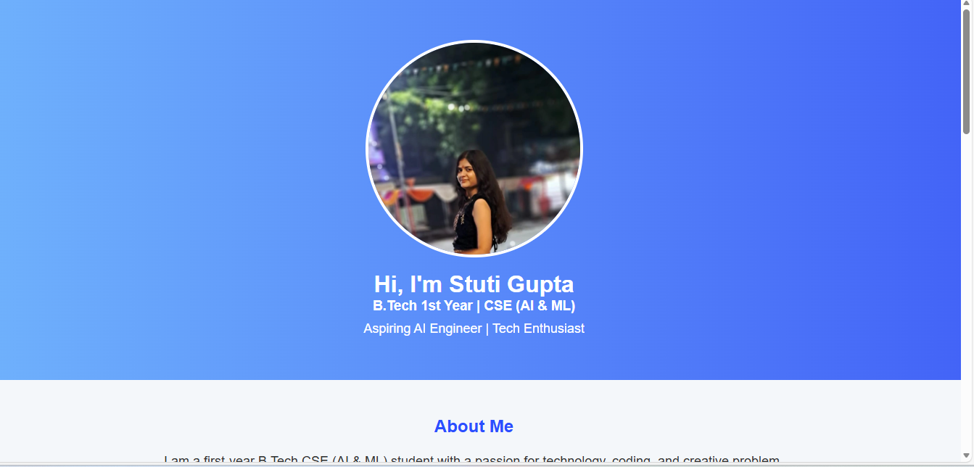
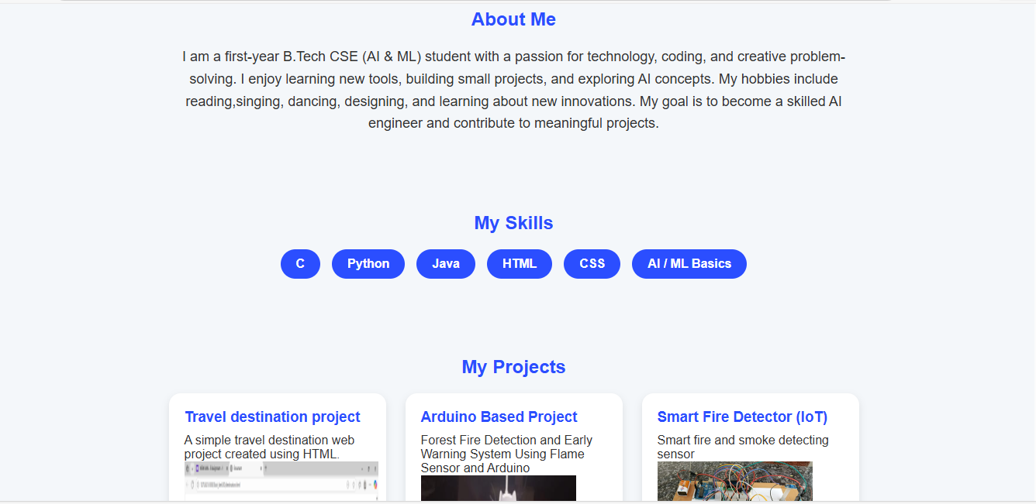
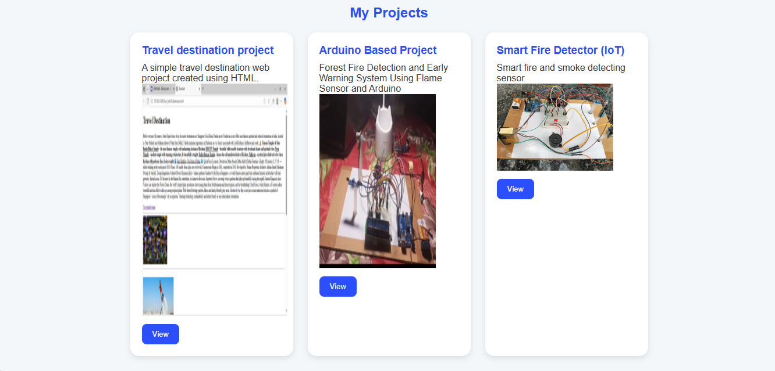
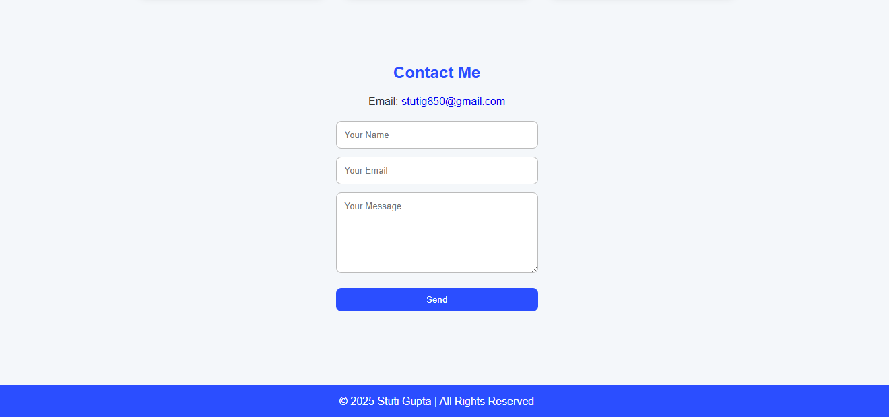

NAME: STUTI GUPTA(CSE AIML)
Section: E

